ARP Poisoning

**Open the Ettercap using the command. It take time to initialize so wait for some seconds.**

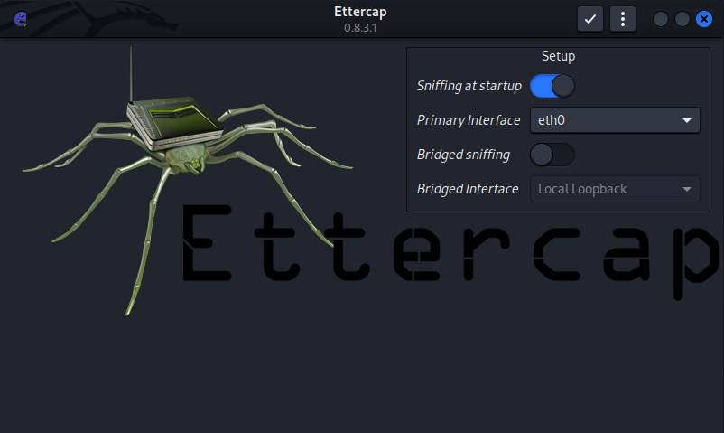

**Click for the “SCAN FOR THE HOST”.**

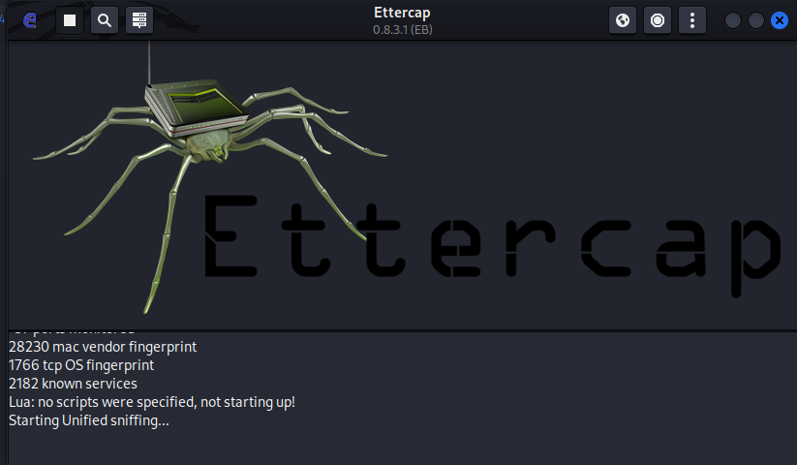

**SCAN detect list of HOST”**



**Before start the attack we have to activate the “ip_forward” commands**

**Run the “wireshark” as root privilage mode.**

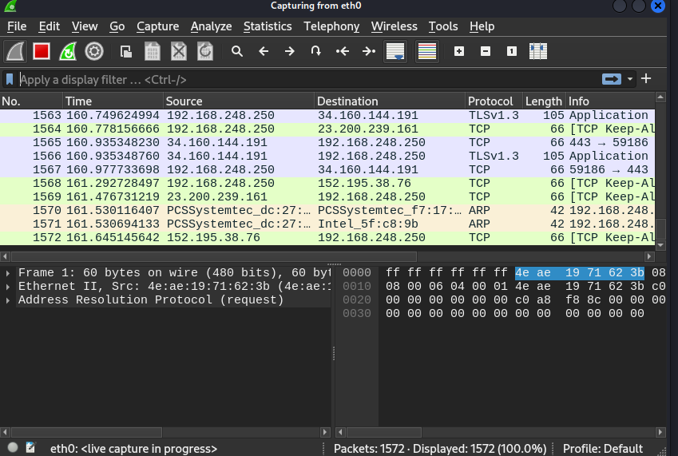

**Start MITM attack using ARP Poisoning. Attack is started on selected target**

**Ones the login is perform the system will capture the login request.**

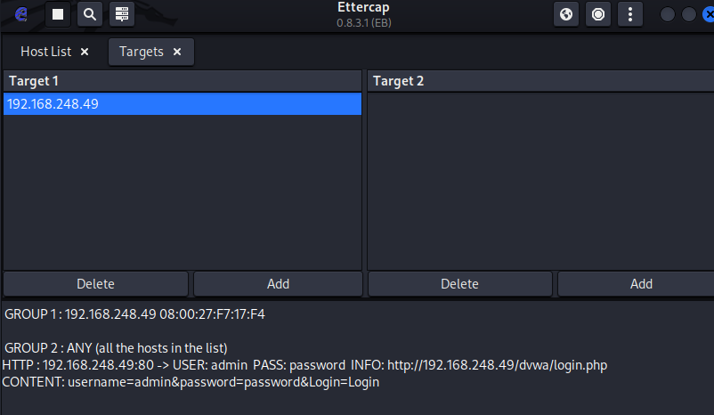

**Stop the wireshark and save the packet in .pcap file.**

**Analyze the packets at “https://apackets.com/”**

